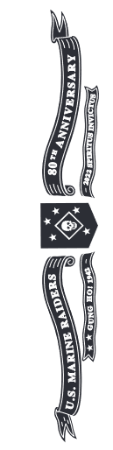


SPECIAL EDITION U.S. MARINE RAIDER STILETTO HONORS
THE 80TH ANNIVERSARY OF
AMERICA’S FIRST ELITE FORCE UNIT!

The Raiders were well-armed, with more automatic weapons (and Boys .55-cal. “Elephant Guns”) and knives than any other battalions of the Corps …

“Your rifle you sleep with and treat as your wife. Your knife is your comrade, and may save your life –”
~Raider Rudy Rosenquist (3DM & K Co.); Former President and Board Member; U.S. Marine Raider Assn.

“They carry machine guns like pistols … And a knife that was tempered in hell.”
~Raider Vern Akers (2HQ, A, B); Former Board Member, U.S.M.R.A.

“We were men who longed for battle; destruction was our skill …”
~3d Bn Marine Raiders
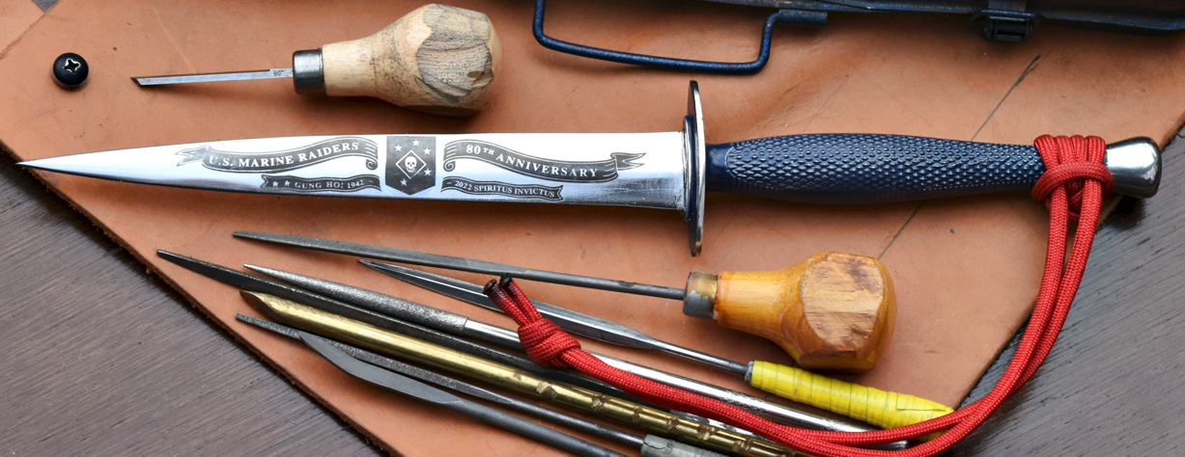
Ahoy Marine Raiders, Elite Force Admirers and Friends:
T
oday we bring you news about the famous Marine Raider Stiletto that was “Tempered in Hell” -- from combat in Tulagi and Makin Island, through Guadalcanal, and all the way up the Solomons to Bougainville. combat-proven in jungle fighting, the Marine Raider Stiletto was the first fighting knife developed expressly for Marines. And the Raiders were the first Elite Force Unit formed by the U.S. in World War II.
Churchill enthusiastically
endorsed his British Commandos to FDR and recommended the U.S. form such a unit. FDR told his son, Maj. Jimmy Roosevelt, USMCR, to grease the skids.
The Marine Raiders were the first elite force our country, fielded ahead the Rangers, the First Special Service Force and the Navy Frogmen, the Raiders were the first such unit to carry the fight to the enemy – payback for Pearl Harbor!
Our countrymen back on the home-front loved it. Stories of the gallant Marine Raiders on their famous Makin Island Raid of 17-18 August 1942 hit the open arms
of our newspapers, and movie theater newsreels – just when America needed a victorious morale booster! The Raiders were transported in submerged subs and then surfaced to paddle and motor ashore in rubber boats in heavy surf in the post-midnight hours. So exciting a Hollywood movie, “Gung Ho!”, was made about it, with the big “Star” of the day, Randolph Scott.
It's been 80 years since those historic days when the Raiders were handpicked and volunteered for this “Suicide Outfit", whose name was kept alive by its fame -- and now, by today, MARSOC Marine Raiders of SOCOM.
“Marine Special Operations Companies (MSOCs) deploy to climes and places all over the world, where they perform the entire spectrum of SOF (Special Operations Forces) functions. [It] receives less than two percent of SOCOM’s budget, yet it … takes on a disproportionate ten percent of its missions.” -- Marine Special Operations Command Historian, Benjamin J. Wilson.
The Raiders were based on the British Commandos. The Commandos’ knife, the Fairbairn-Sykes Fighting Knife, inspired the Raiders’ Stiletto. The British connection is carried forward in this special edition Raider Stiletto, in that, like the Brits’ fighting
knife, the blade is made in England's knifemaking center, Sheffield, England, under the authority of wartime supplier, H.G. Long & Co., established in 1849.
The blade is hardened, tempered, sharpened and, remarkably, mirror polished British Stainless Steel, as beautiful as on the finest custom knives.
Only a relatively few were made, only about 5% as many as the Army’s M3 trench knife, and fewer yet of these survive today. Most of the wartime Stilettos show signs of use, heavy wear and age. Even so, due to their rarity and significance, they bring at least $1,000 (good ones bring $3,000-$4,000).
To continue the tradition of rarity, this is a limited edition of only 80 (for the 80th Anniversary) with the Wartime “Grey” Finish and 80 with the “Dress Blues” Finish. Each is serially numbered between 01 and 80 – only 2 knives for each of the 80 years since the Raiders’ founding, for a total of only 160. Each is verified with a matching-number, signed Certificate that accompanies it.
Each features upgraded materials, including the blade of high-quality British Stainless Steel (so, unlike the originals, they will not rust). The hilt of hot-poured, genuine Pewter (which won’t crumble over time like the wartime originals of an
experimental alloy).
Each “Dress Blues Finish” is reminiscent of the Corps’ Dress Blues, in a hard, porcelain-like, clear-coat finish, with a Marine Corps Scarlet wrist lanyard, the color of the “Blood Stripe” of this distinguished uniform.
_____ “Wartime Grey” Finish
_____ “Dress Blues” Finish

All who see either Stiletto will be impressed with it and will be pleased to know that it is keeping alive the memory of the gallant, history-making U.S. Marine Raiders.
By the next major 85th Anniversary in 2027, even the youngest Raider would be over 100.
When you reserve this authentic U.S. Marine Raider Stiletto, your satisfaction is guaranteed – or return it within 60 days for a full refund, including shipping expenses both ways – no problem; no questions.
Gung Ho! Spiritus Invictus!
Robert A. Buerlein, President
Director Emeritus,
Marine Raider Association
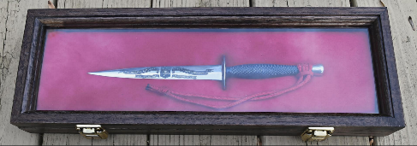

Optional Display Case: $59.
American Dark Oak, with locking glass lid and wall mounts, for proud display in your home, office or War Room; 6” x 16” x 2”. The liner is draped in Marine Corps Scarlet, to secure and protect your Marine Raider Stiletto.
Order: By Phone: 804-257-7144
By Mail: Historical Associates; 6767 Forest Hill Avenue; Suite 315; Richmond, VA; 23225
On Website: (Credit cards or PayPal); http://www.historicalassociates.com/
ALL KEPT CONFIDENTIAL
_____ Please reserve with a deposit (refundable) of $49. Invoice balance due prior to delivery.
_____ I wish to pay in full: _____ Knife, $249; _____ Display Case, $59.
Delivery: _____ In CONUS/48 States, $15; _____ Outside CONUS/48 States, $30
_____ Add Display Case Delivery, $5
Deliveries within Virginia (only), please add 6% sales tax: _____
Amount to charge/pay now: $___________ Total: $ ___________
_____ PayPal _____ Visa _____ MC _____ Discover _____ AmEx _____ Check or M.O. (To: “Historical Associates”)
Name ____________________________________________________________ Daytime Phone (____)__________________
Street Address ___________________________________________________________________________________________
City/State ________________________________________________________________________ Zip ___________________
Card No. ___________________________________________________ Sec. Code __________ Exp. Date _______________
Email __________________________________________________________________________________________________

